Welcome to the 2023- 2024 school year!

My name is Mrs. Tequila Williams I'm married, I have two girls 15 & 10, my favorite color is Purple and I love to spend time with my Family. I am very excited to start my six year here at Meadowbrook and look forward to teaching your child in 2nd grade. We will be working hard to master many new skills. This year, we will be reading to learn and focusing on comprehension. Vocabulary understanding is a key component in all subject areas. We will learn our grammar skills throughout our writing. In math, we will work on number sense, operations, addition and subtraction. We will also be learning about science, health, and social studies.

**Supplies:**

Please provide the following supplies for your child.

* Loose leaf notebook paper(an abundance)
* 4 composition notebooks
* Pencils an abundance (no mechanical)
* 2 large bottle of Hand Sanitizer
* 2 Clorox wipes/Disinfecting wipes
* 2 boxes of Kleenex - Erasers (an abundance)
* Gallon and Quart sized Ziploc bags
* 1 pack of index cards
* Box of crayons (to be kept at home)
* 1 pair over the Ear Headphones (no earbuds)
* 4 plastic folders with prongs and pockets

**\*No Pencil Sharpener or Scissors\***

**Please make sure your child has supplies at home to use for homework too!**

**Questions/Contact**

If you have questions about anything or need to let me know about something, you can send a note with your child or you may call 706-796-4915 during my planning 10:10-10:55, or after school 3:30- 4:00. Other times, I am in the classroom teaching and cannot get to the phone. **E-mail and Class Dojo is the best way to get a message to me willite1@boe.richmond.k12.ga.us. I will check it at least 3 times per day.**

.

Our classroom uses Class Dojo. This is an online behavior management tool. You will be able to see your child’s daily progress with the pass code you will receive.

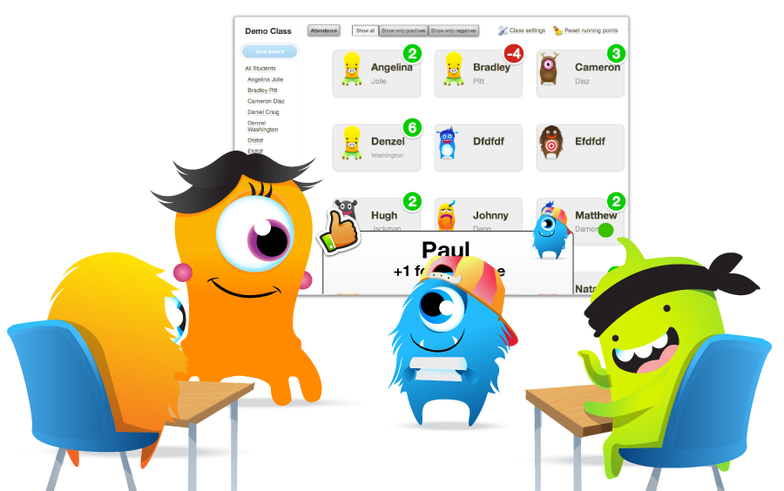**Classroom Rules:**

* Be respectful and Listen
* Raise Hands
* Do not Yell Out
* Follow Directions
* Be ready to learn
* Keep hands, feet and objects to yourself
* No Gum